## Lesson 11 – Activity Sheet

## Task 1 Getting Started

Take your speaker or pair of headphones and wire them up as shown in diagram below

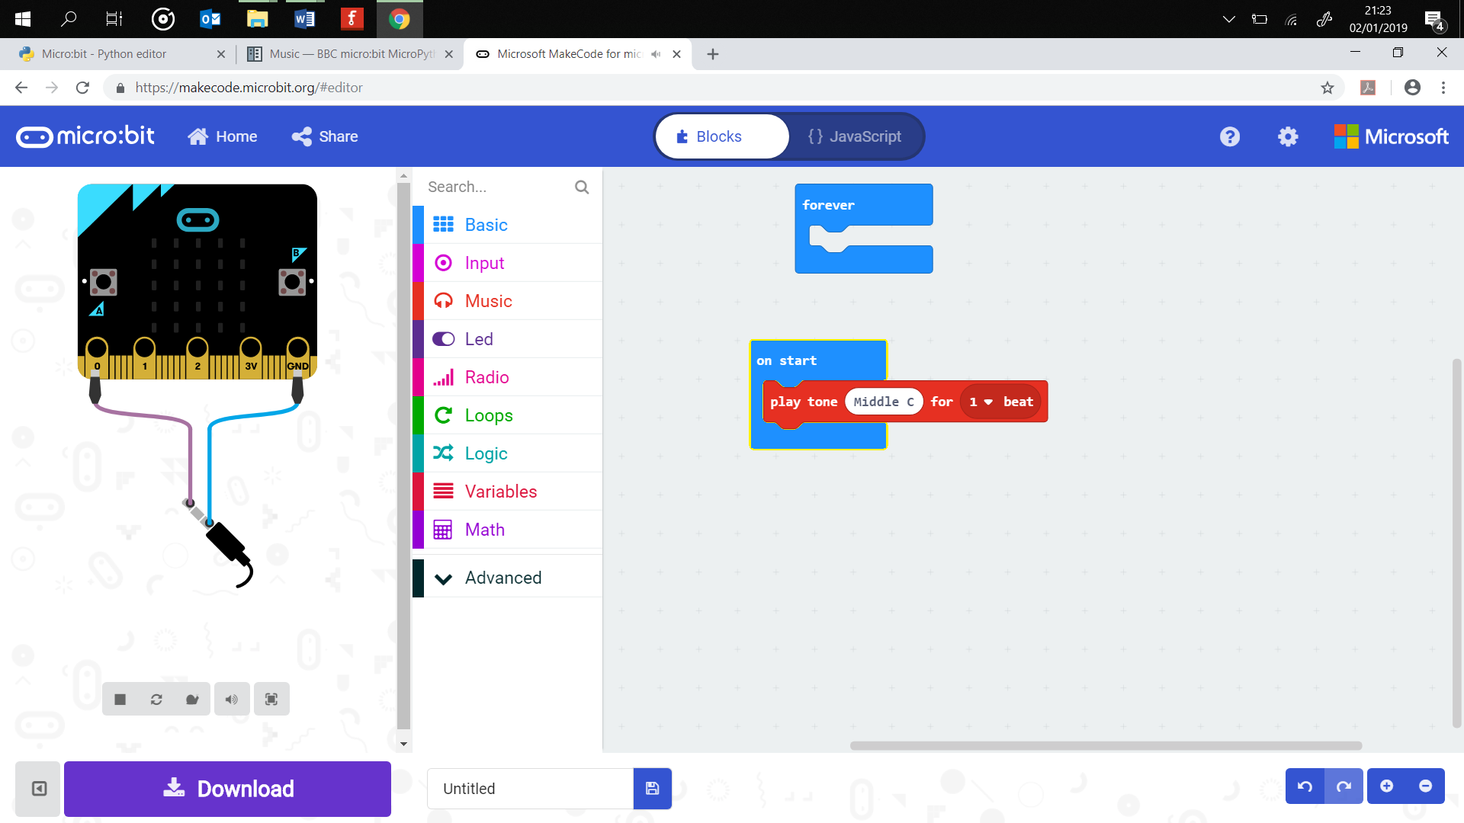

This enables you to play sounds and music which was covered in Lesson 6. What you probably didn’t know is that the micro:bit also has its own speech synthesiser which means that we can program it to speak. Write up the program below and download it to your micro:bit.

from microbit import *

import speech

speech.say("Hello, World")

Change what it says on line three by adding your own sentence.

We can also adjust how the voice sound by altering the following elements:

* Pitch – how high or low the voice sounds (0 = high, 255 = low)
* Speed – how quickly the device talks (0 = to fast, 255 = very slow)
* Mouth – how well the words are enunciated (0 = ventriloquist, 255 = Shakespearean actor!)
* Throat – how relaxed or tense the voice is (0 = very tense, 255 = calm)

Try out this version of the program:

from microbit import *

import speech

speech.say("How are you?", speed=110, pitch=100, throat=100, mouth=200)

Sounds very robotic – can you adapt the values so that it sounds more human like?

## **The micro:bit Performance**

Since you can now make your micro:bit speak we can create a simple performance for your class.

1. How about writing a program so that your micro:bit reads out your favourite poem or a short story?
2. Why not create a song lyric quiz where your micro:bit reads out a single line from a song. Other learners then have a few seconds to guess what it is and write it down. You can automate the quiz by using the sleep() function. Use the example code below as a starting point.

import speech

from microbit import sleep

# The one song lyric quiz.

speech.say("I don’t want a lot for Christmas")

sleep(5000)

speech.say("Here I am floating in my tin can")

sleep(5000)

1. Use the musical notes from Lesson 6 and combine them with the speech to perform a song. Use the example code below as a starting point.

import music

tune = ["C4:4", "D4:4", ADD YOUR NOTES]

tune2 = ["C8:4", "E4:4", ADD YOUR NOTES]

music.play(tune)

speech.say("I don’t want a lot for Christmas")

music.play(tune2)

## Success Criteria

* The micro:bit speaks
* The micro:bit speaks with a level of realism ( good clear voice)
* Notes and speech are combined to create a musical performance.

## Pro-tip

Success and the quality of the speech depend on the effective use of the speed, pitch, throat and mouth settings. It is worth spending time testing out the best values for your performance.

## Test Time

Ensure that the wires are connected correctly and securely to your micro:bit, then download your project and listen to it. You will need to adjust the speed, pitch, throat and mouth to find a good sounding voice.

## Stretch Tasks

* Create a chat bot which answers questions with answers which are selected from a random list. The key here is to ensure that the answers are open ended, for example, ‘I think it is so’ is better than ‘Yes’,
* Use the LED matrix to add images, a face or emotions to your project. Perhaps you can adapt it to make it appear as if your micro:bit is talking or singing to you.

Task 2 - Getting Started

Combine the music code and speech code to program a musical micro:bit performance for your teacher and class.

Success Criteria

The musical performance must have:

* Music
* Speech

**Some Ideas**

Here are some possible ideas that could be programmed:

* Program the micro:bit to sing and play your favourite song?
* Build a rapper machine that spits out hot bars
* Compose an original theme tune for a film
* Create a backing track which you sing over the top of

**Design**

None required for this project

## **Materials Needed**

## Headphones / speaker and crocodile clips.

## Pro-tip

Try and make use of the rest code as this adds pauses to your melody and will improve the overall feel of the music that you have created.

## Test Time

Download your musical performance to your micro:bit and test it. Make any required improvements to the program.

## Stretch Tasks

* Use the LEDs to add images or lights to your performance
* Add more than one tune that is controlled by the buttons

## Final Thoughts

I bet you never knew that the micro:bit could speak. Think of all the applications of program generator speech across technology. You could make an alphabetically list of all uses, A = Alexa, B = Bingo machine.

The musical performance will be scored by the other students and the overall winner selected. Ensure that you use both music and speech to access the points.